Netgear Switch Stand

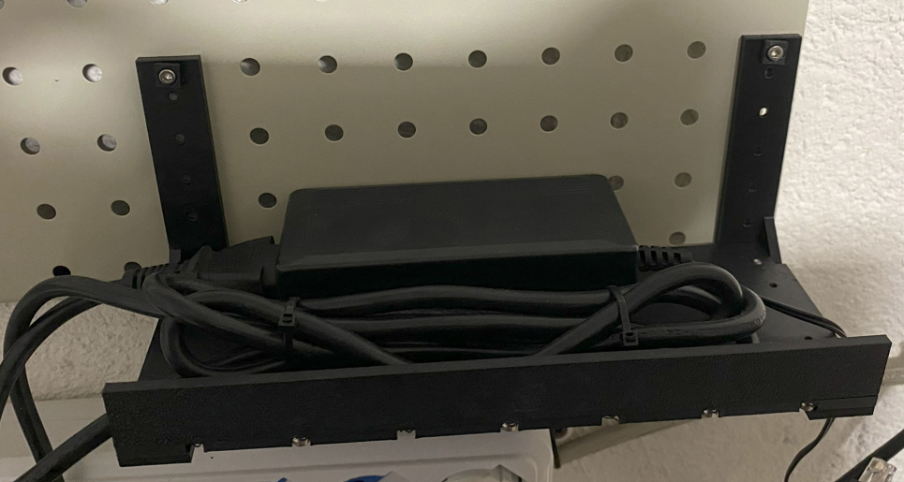

Project Goals
This is a kit to mount a Netgear switch to a Metal Pegboar

Amazon DE: https://amzn.eu/d/8XqDu2Y
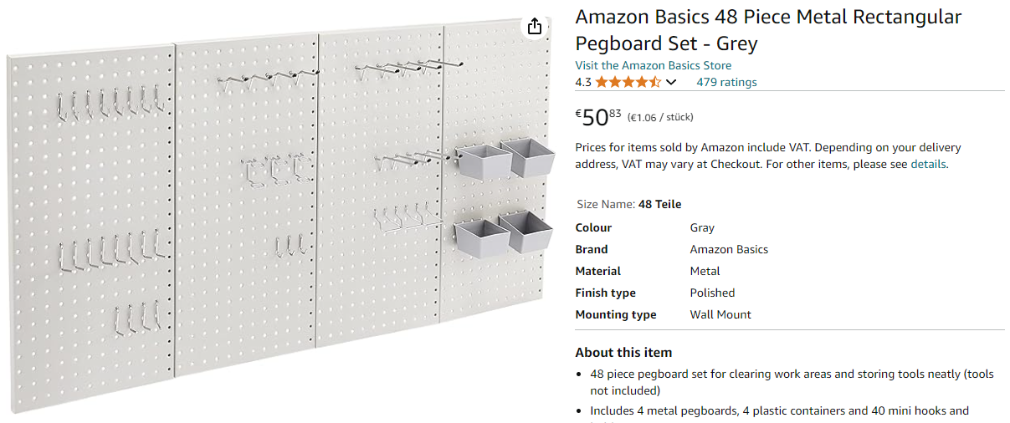

Amazon.it: https://amzn.eu/d/7wQn8La

Holes distance: 25.4 mm
Holes size: 6.6 mm

Components
- Bracket for the switch
- Shelf for Power Supply and Power Cable
- Expansion Anchor for Pegboard

